**MBUYA PARENTS’ SCHOOL**

**P.1 LITERACY B LESSON NOTES TERM III**

**THEME 9: OUR TRANSPORT**

Sub theme1: types and means of transport.

What is transport?

Transport is the movement of people, goods and services from one place to another.

Types of transport.

Road transport air transport

Water transport railway transport

Activity

1. What do we call the movement of people, goods and services from one place to another?
2. Mention any two types of transport.
3. Give any three examples of goods you know.

Means of transport.

Means of transport are the things that help us to move from one place to another.

Road transport.

Road transport is the commonest type of transport.

Means of road transport.

car bicycle bus

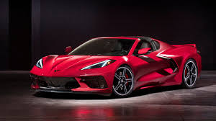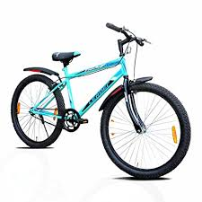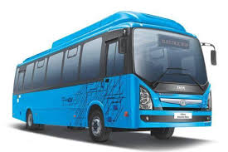

motorcycle donkey camel

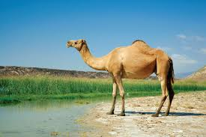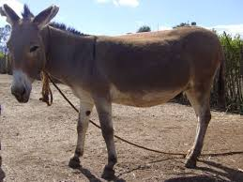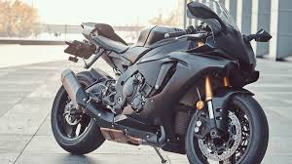

cart lorry horse

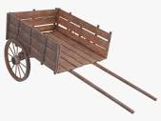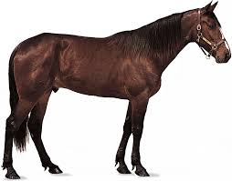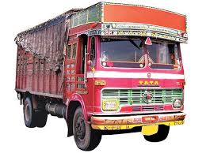

W

Activity

1. What is the commonest type of transport?
2. Name any four means of road transport.
3. Draw these means of road transport.

Bus bicycle

Road users

Road users are people who use the road.

Examples of road users.

Pedestrians bi- cyclists

riders motorcyclists

passengers drivers

Note: Pedestrians are people moving along the road on foot.

Passengers are people travelling by car, lorry or bus.

Drivers are people who drive vehicles.

Bi- cyclists are people who ride bicycles.

Motorcyclists are people who ride motorcycles.

Activity

1. Identify any two examples of road users.
2. What do we call people moving along the road on foot?
3. People travelling by car or bus are called……………………….

Water transport.

Water transport is the slowest type of transport.

Means of water transport.

Means of water transport are things which help us to move from one place to another on water.

These are:

Canoe ship ferry

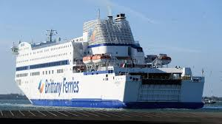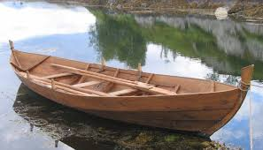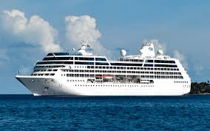

Boat

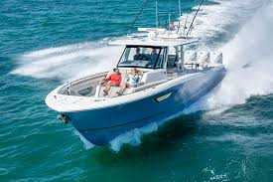

Activity

1. What is the slowest type of transport?
2. Circle means of water transport.

Boat, bus, bicycle, ferry

1. Draw these means of water transport.

Ship boat

Means of air transport.

Means of air transport are things that help us to move from one place to another in air.

These are:

helicopter parachute

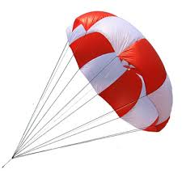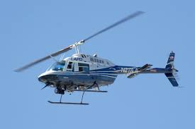

aeroplane rocket

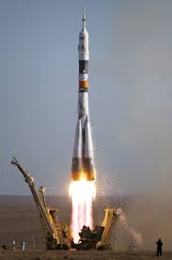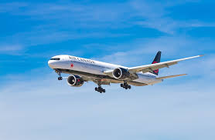

air balloon

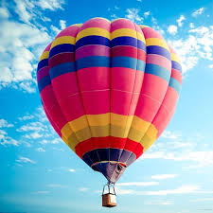

Note: Air transport is the quickest type of transport.

Activity

1. Write out means of air transport.

Camel lorry helicopter ……………

Boat rocket car ……………..

1. Draw these means of air transport.

Aeroplane rocket

1. What is the quickest type of transport?

Railway transport

Means of railway transport.

Train

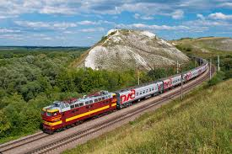

Activity

1. Match types to means of transport.

Water transport motorcycle

Air transport ship

Railway transport rocket

Road transport train

1. Draw a train.
2. Write yes or no.
3. A train moves on a railway line…………..

B) An aeroplane moves on the road…………

c) A car is a type of transport…………..

d) A ship move on water………………..

Animals used for transport.

donkey camel horse

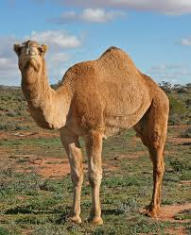

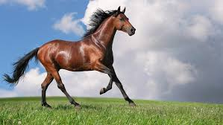

ox

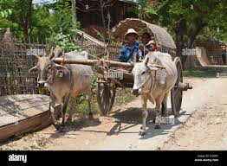

Activity

1. Name any two animals used for transport.
2. Why do people keep donkeys at home?
3. Identify these animals used for transport.



…………………… ………………..

People who help us in transport.

1. Driver: drives vehicles.
2. Captain: sails a ship /commands a train.
3. Bi- cyclist: rides a bicycle.
4. Pilot: flies an aeroplane.
5. Conductor: collects money in a taxi or bus.
6. Sailor: sails a boat.
7. Motorcyclist: rides a motorcycle.
8. Astronaut: flies a rocket.

Activity

1. Write people who help us to move the following
2. Lorry, car…………………
3. Aeroplane………………
4. Ship……………………
5. Bicycle………………..
6. What do we call a person who collects money in a bus or taxi?
7. An astronaut flies a…………………..

Means of transport and their places.

Mean of transport place

Bus bus park

Taxi taxi Park

Motorcycle stage

Aeroplane airport

Train railway station

Ship harbour

Boat landing site

Helicopter airstrip

Activity

1. Match correctly.

Bus landing site

Train bus park

Boat airport

Aeroplane railway station

1. What is the biggest airport in Uganda?
2. Draw and name any two means of transport.

Uses of transport.

1. Transport help people to move from one place to another.
2. Transport saves time.
3. Transport help people to move their goods from one place to another.
4. People earn money from transport.

Activity

1. Underline people who earn money from transport.

Drivers, car, conductors, train, sailors

1. How is transport important to people?

Communication

What is communication?

Communication is the sending and receiving of messages.

Types of communication.

1. Verbal communication.
2. Non-verbal communication.
3. Written communication.

Activity

1. What do we call the sending and receiving of messages?
2. Give any two types of communication.

Means of communication.

Means of communication are things we use to send messages to people.

They are grouped into two:

Traditional means of communication.

Modern means of communication.

Means of traditional communication.

Drums whistle fire/ smoke

Ash horns gestures

Activity

1. Identify these means of traditional communication.

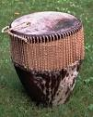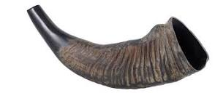

……………….. ………………..

1. How is a drum important to people?

Means of modern communication.

television radio

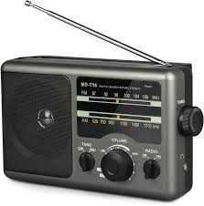

telephone/ mobile phone newspapers

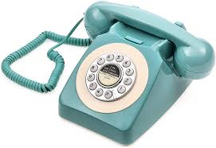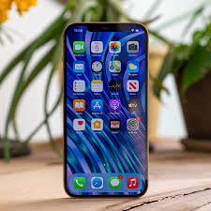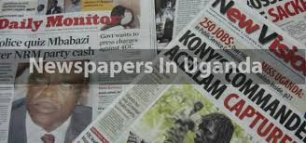

bell computer magazines

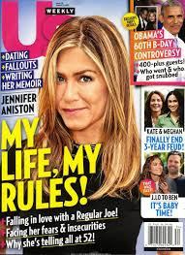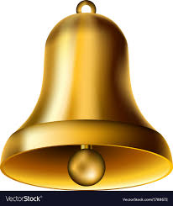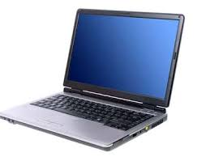

Writing letters

Activity

1. Underline means of modern communication.

horns, television, drum, radio, fire, newspapers

1. Name these means of communication.





…………………….. ………………

THEME 10 THINGS WE MAKE

Sub –theme 1: Things we make at home and school.

Crafts

Crafts are things made out of local materials using hands.

Examples of crafts.

Dolls mats balls

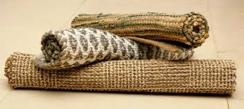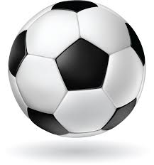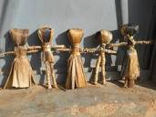

Stools hat basket

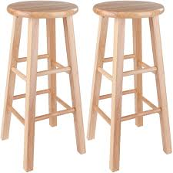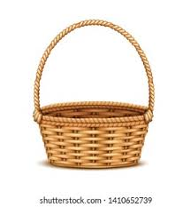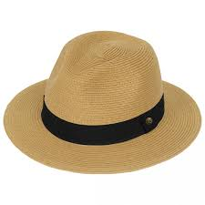

Brooms pots drum

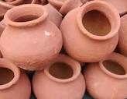

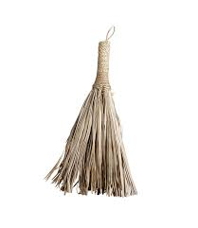

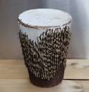

Ropes, cups, chairs, tables, necklaces, kites, pestle etc.

Activity

1. What do we call things made out of local materials using hands?
2. Mention any four examples of crafts.
3. Draw these crafts.

Brooms pot hat

Things we make from clay.

Clay soil is the best soil for modelling. We get clay from the swamp.

Things made from clay are called ceramics.

Examples of ceramics.

Pots charcoal stove cups

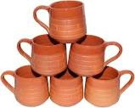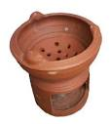

Plates flower vase bricks

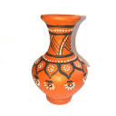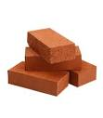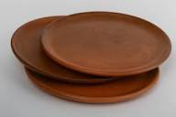

Max pans, roofing tiles, floor tiles, candle stand

Ceramics are baked in a kiln to make them stronger.

Note:

A potter is a person who makes things out of clay.

Pottery is an activity of making things out of clay.

Activity

1. What is the best soil for modelling?
2. What do we call things made out of clay soil?
3. Give any four examples of ceramics.
4. Why are ceramics baked in a kiln?
5. Where do people get clay soil?

Things we make from banana fibres.

Banana fibres are got from the banana plant.

Examples of things we make from banana fibres.

Balls dolls ropes

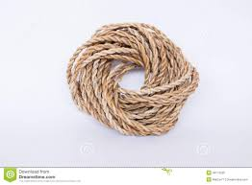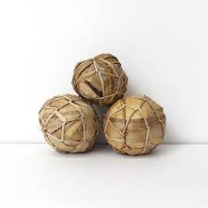

Mats basket door mat

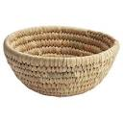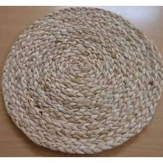

Bag

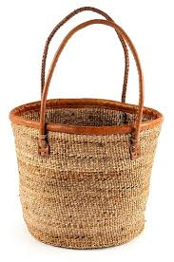

Activity

1. Name the plant below.

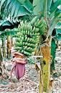

…………………

1. Identify any two things we can get from the above mentioned plant.
2. Mention any three things we make from banana fibres.
3. Draw these things we make from banana fibres.

Bags rope basket

Things we make from palm leaves.

Palm leaves are got from the palm tree.

Examples of things we make from palm leaves.

basket **mat** hat

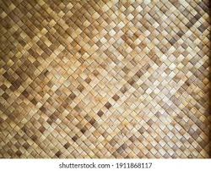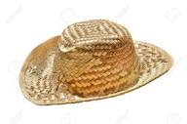

hand bag table mat broom

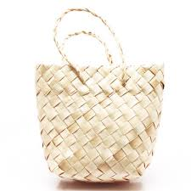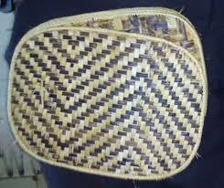

Activity.

1. Name any two things we make from palm leaves.
2. Where do people get palm leaves?
3. Underline things we make from palm leaves.

cups, hat, broom, plates, bricks, mat

Things we make from sisal.

We get sisal from the sisal plant.

Examples of things we make from sisal.

Rope fishing net door mat

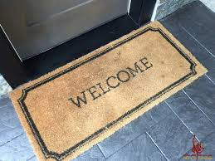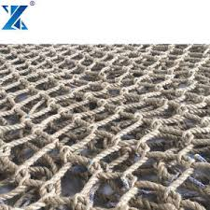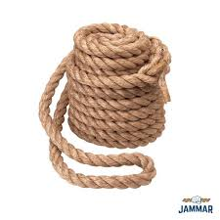

Polishing brush sisal sack painting brush

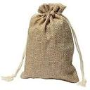

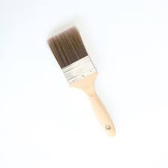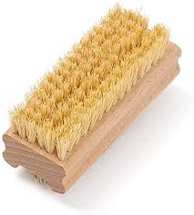

Activity

1. Where do we get sisal from?
2. How is sisal important to a fisherman?
3. Draw these things we make from sisal.

Rope fishing net

Things we make from wood.

Things we make from wood are called furniture.

A person who makes furniture is called a carpenter.

A place where furniture is ma de is called a work shop.

Examples of furniture.

Chair table bench

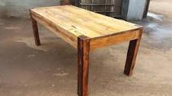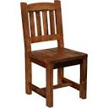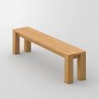

Mortar cupboard pestle

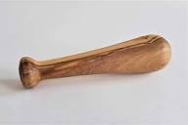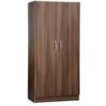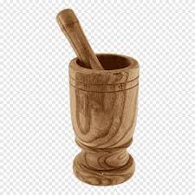

Ward robe door window

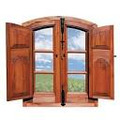

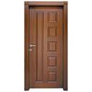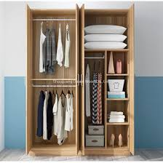

Bed, desk, coffin, mingling stick

Note: Carpentry is an activity of making furniture.

Activity

1. What do we call things made out of wood?
2. A person who makes furniture is called a……………………..
3. What do we call a place where furniture is made?
4. Draw these things we make from wood.

|  |  |  |
| --- | --- | --- |
| mortar | bed | pestle |
|  |  |  |

1. How is a forest important to a carpenter?

Things we make from metal.

Spoon fork chair

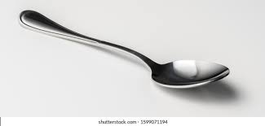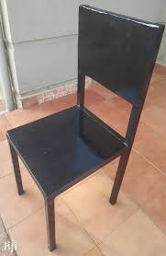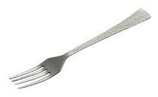

Ladle saucepan kettle

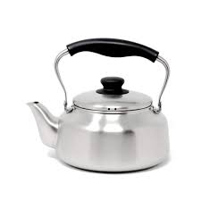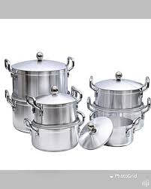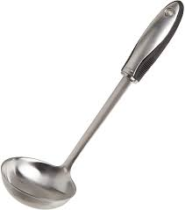

Bell bed table

Note: Welding is an activity of making things out of metal.

Activity

1. Name any four things made out of metal.
2. What is welding?

Things we make from animal skin.

Things we make from animal skin are called animal skin products.

Examples of animal skin products.

Shoes belt jacket

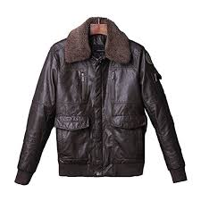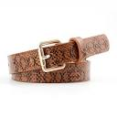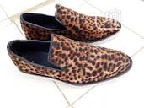

Drum hat

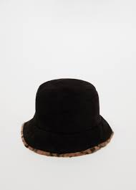

Activity

1. Name any four animal skin products.
2. Write any two animals which provide man with skin.

Things we make from plastic.

Jerry can bottle forks

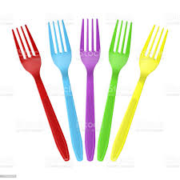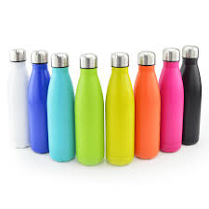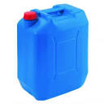

Plates basin jug

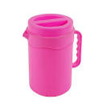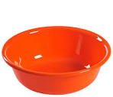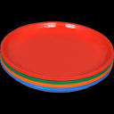

Chair bucket spoons

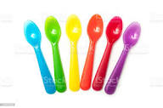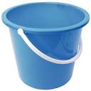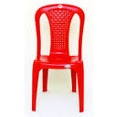

Activity

1. Name any two things we make from plastic.
2. Match correctly

Clay table

Metal mat

Palm leaves pot

Wood saucepan

1. Identify any two things we make from;

a) banana fibres ………..... …………

b) wood …………… ……………..

c) sisal ………………… ……………

Sub theme 2 Materials and their sources.

Materials used to make crafts.

Palm leaves sisal

Banana fibres clay

Plastic wood

Papyrus bottle tops

Wires papers

Sticks threads

Animal skin

Activity

1. Mention any four materials we use to make crafts.
2. Write the material used to make the following crafts.

Bed………………………

Mat……………………..

Basin……………………

Flower vase……………

1. How is clay important to a potter?

Materials we use to make crafts and their sources.

Material source

Banana fibres banana plant

Palm leaves palm tree

Clay swamp

Sisal sisal plant

Wood forest

Sticks bush, forest

Animal skin animals

Note: Some materials like threads, wires, plastic are got from shops and factories.

Ways of making crafts.

1. By weaving like baskets, bags, mats, hats
2. By knitting like sweaters, socks, bed covers, table cloth
3. By modelling like pots, charcoal stove, plates, flower vase.

Activity

1. Match the materials to their sources.

Clay palm tree

Wood banana plant

Banana fibres swamp

Palm leaves forest

1. Write down two things made by;
2. Weaving……………… …………..
3. Modelling…………….. ……………
4. Knitting……………….. ……………

Sub theme 3 Importance of things we make.

Importance of things we make.

1. For decoration.
2. For sitting on like chairs, desks ,mats
3. For playing with like dolls, balls
4. For wearing
5. For writing like pens, chalk, pencils
6. For sleeping on.
7. For telling time.

**Activity**

1. Why do people make chairs?
2. Mention any two things we make for writing.
3. Draw these things we make for wearing.

Sweater socks

1. How is a ball useful at home?

THEME 12 PEACE AND SECURITY

Sub-theme 1 People who keep peace and security.

What is peace?

Peace is when people are free from danger.

What is security?

Security is safety of people’s lives and property.

People who keep peace and security.

Policemen parents

Children guards

Solders prefects

Religious leaders local council leaders

teachers

Activity

1. Mention any four people who keep peace and security.
2. Identify any two religious leaders.
3. Write L.C in full.
4. Who heads a local council?

Roles of people who keep peace and security.

Parents:

Parents provide basic needs to children.

Parents guide and counsel children.

Policemen

Policemen keep law and order.

Policemen protect people and their property.

Teachers

Teachers guide and counsel children.

Teachers give rules and regulations to children.

Religious leaders

Religious leaders pray for peace.

Religious leaders preach the word of God/Allah.

Children

Children obey rules and regulations.

Children report bad behaviour to elders.

Tools used to keep peace and security.

Activity

1. How do children help to keep peace and security?
2. Who keeps law and order in the community?
3. Parents provide basic needs to children.

Identify any two basic needs you know.

Tools used to keep peace and security.

Baton gun spear

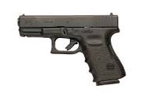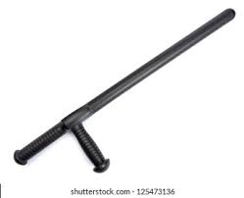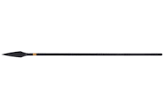

Bomb holy books tear gas

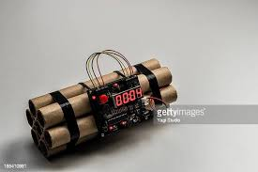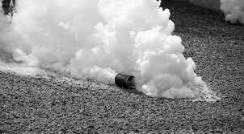

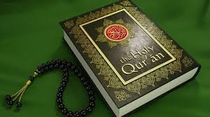

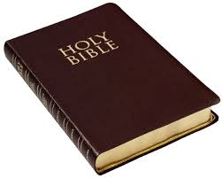

Bow and arrow

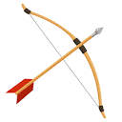

Activity

1. Name any four tool used to keep peace and security.
2. Which animal helps to keep peace and security?
3. Draw these tools used to keep peace and security.

Baton gun

Insecurity

What is insecurity?

Insecurity is living without protection and freedom.

People who cause insecurity.

Robbers kidnappers

Thieves rebels

Causes of insecurity.

1. Poverty
2. Wars
3. Struggle for leadership
4. Divorce
5. Death
6. Theft
7. Diseases

Activity

1. Name any two people who cause insecurity.
2. Why do people fence their homes?
3. Tick causes of insecurity.

Death unity theft guards wars

Effect of insecurity.

Death famine

Poverty displacement

Fear dropping out of school

Hunger divorce

Factors that promote peace and security.

Obedience respect

Sharing helping others

Forgiving one another

Love

Importance of promoting peace and security.

It promotes freedom of speech.

It promotes unity.

It promotes free movement.

Activity

1. Tick ways of promoting peace and security.

Abusing

Loving one another

Fighting

Respect for one another.

1. Give any two effects of insecurity.

END